Question3

#include <stdio.h>

int main()

{

printf("shubham garg");

}

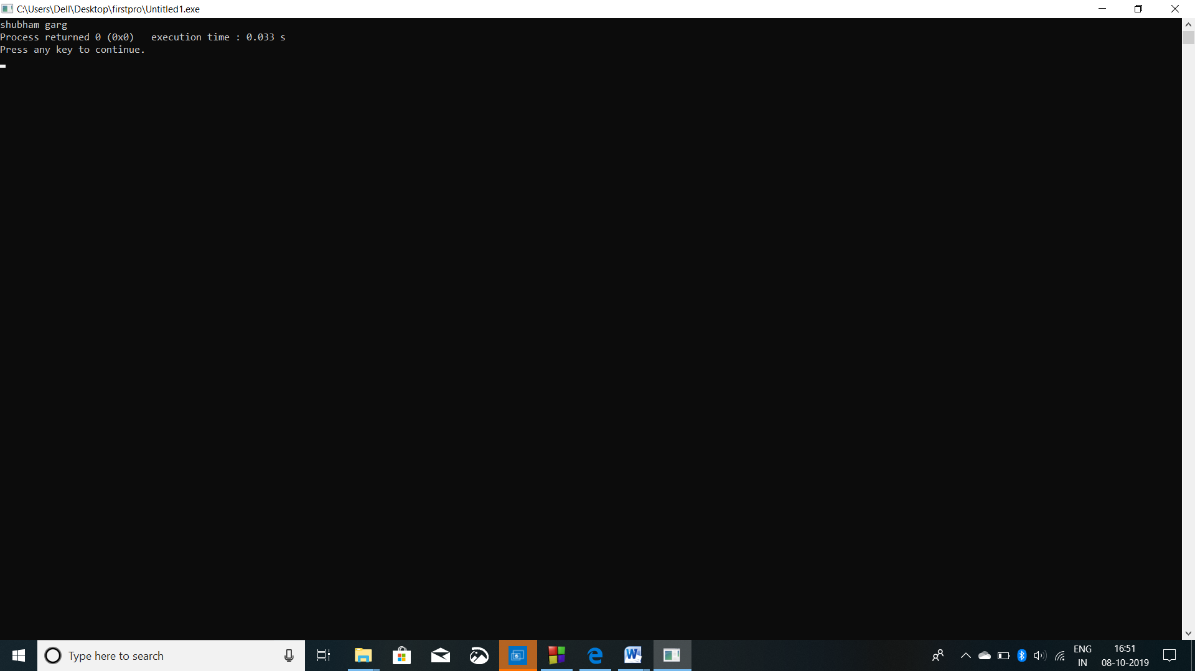

Question 4

#include <stdio.h>

int main()

{

printf("Jaypee Institute of Information Technology");

printf("Near Jaypee Public School");

printf("Jaypee Wish Town");

printf("Noida, India");

}

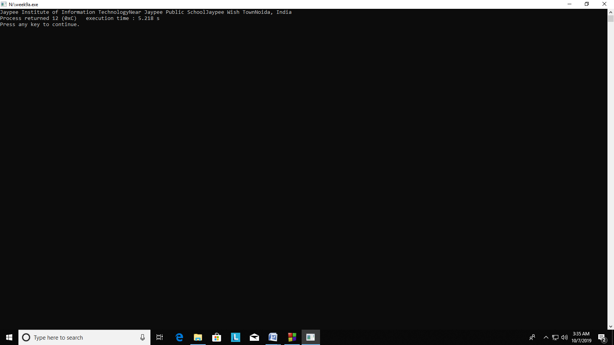

Question 5

#include <stdio.h>

int main()

{

printf("Jaypee Institute of Information Technology\nNear Jaypee Public School\nJaypee Wish Town\nNoida, India");

}

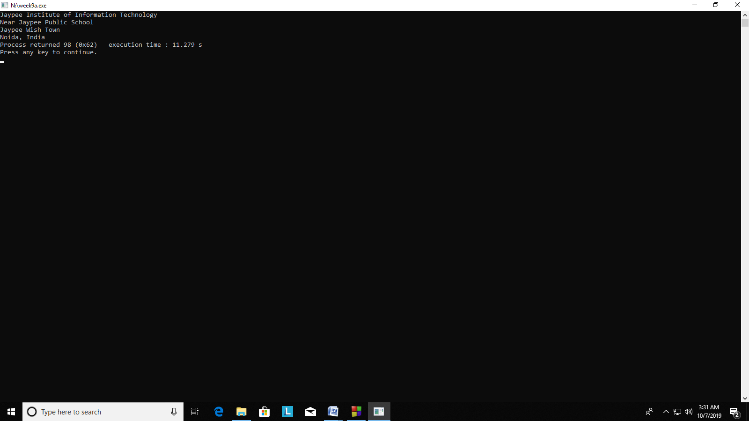

Question 6

#include <stdio.h>

int main()

{

printf("Account No. Name Balance");

printf("\n__________________________________________________________");

printf("\n01690356123 XYZ 1034.54");

printf("\n__________________________________________________________");

}

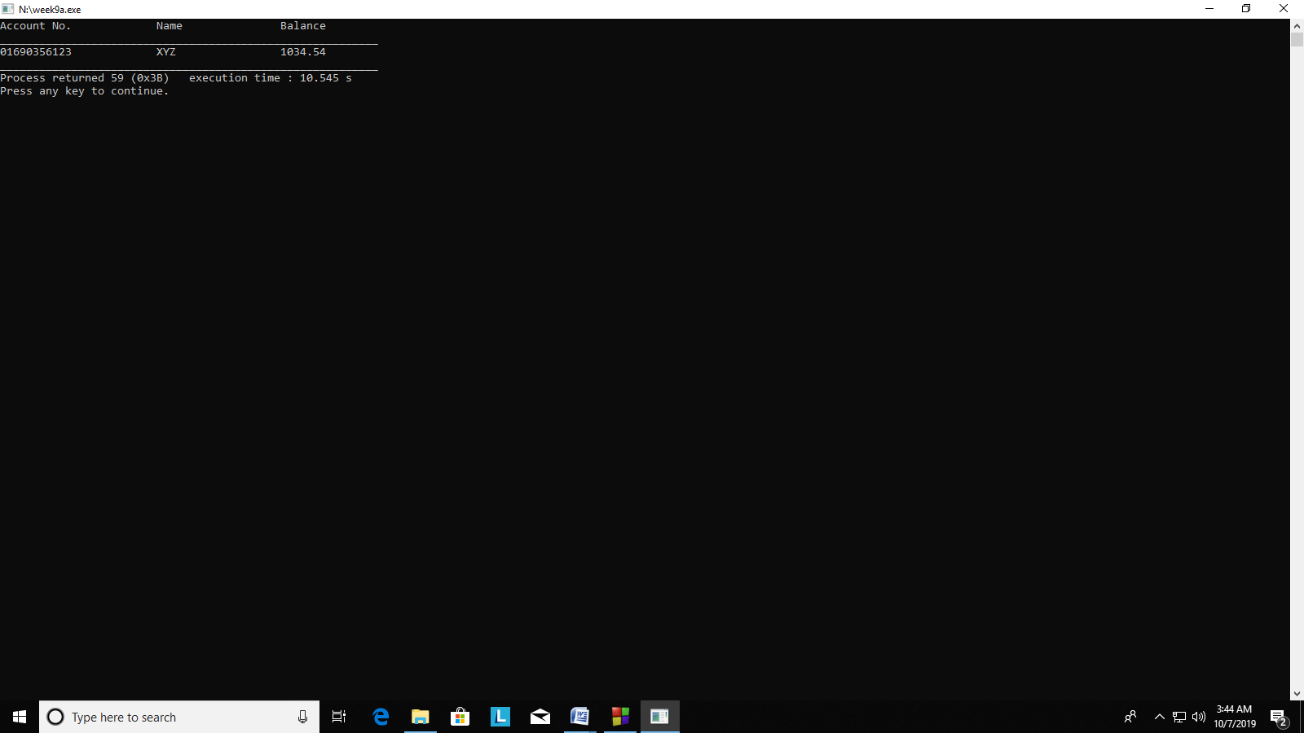

Question 7

(a)

#include <stdio.h>

int main()

{

printf("_ _");

printf("\n___________________");

printf("\n_ _");

printf("\n___________________");

}

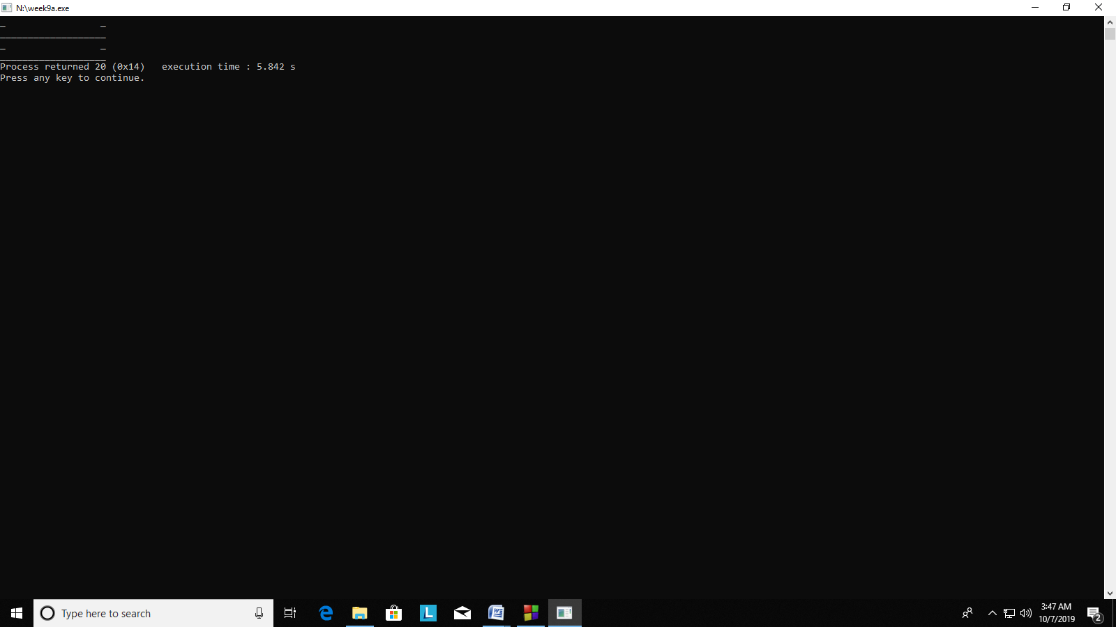

(b)

#include <stdio.h>

int main()

{

printf("********************");

printf("\n* *");

printf("\n* *");

printf("\n*******************");

}

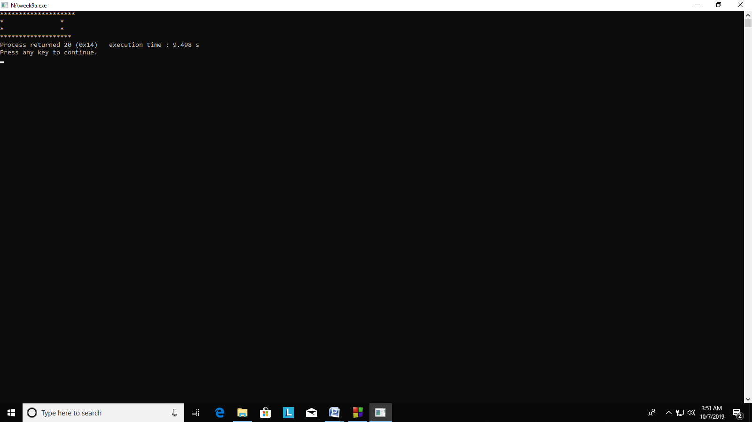

(c)

#include <stdio.h>

int main()

{

printf("+++++++++++++++++++");

printf("\n+ +");

printf("\n+ +");

printf("\n+++++++++++++++++++");

}

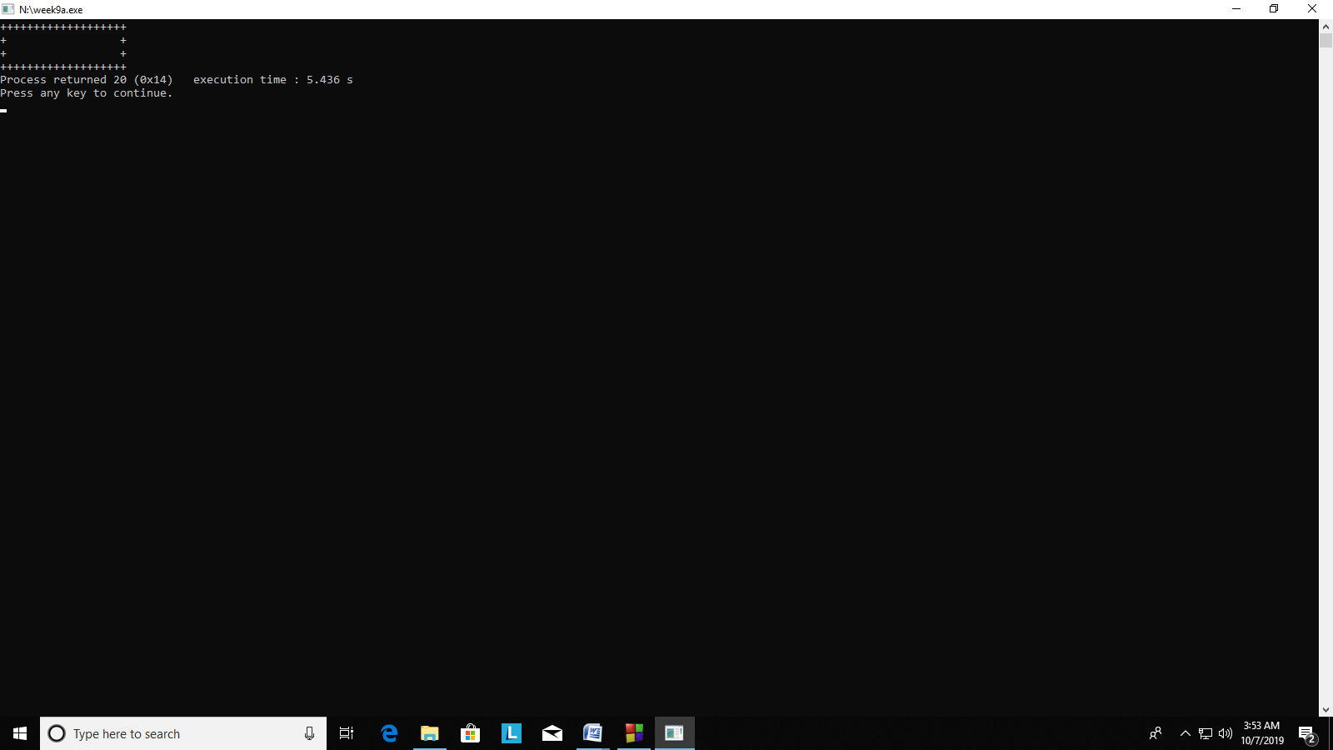

(d)

#include <stdio.h>

int main()

{

printf("__________________");

printf("\n------------------");

printf("\n| |");

printf("\n| |");

printf("\n__________________");

printf("\n------------------");

}

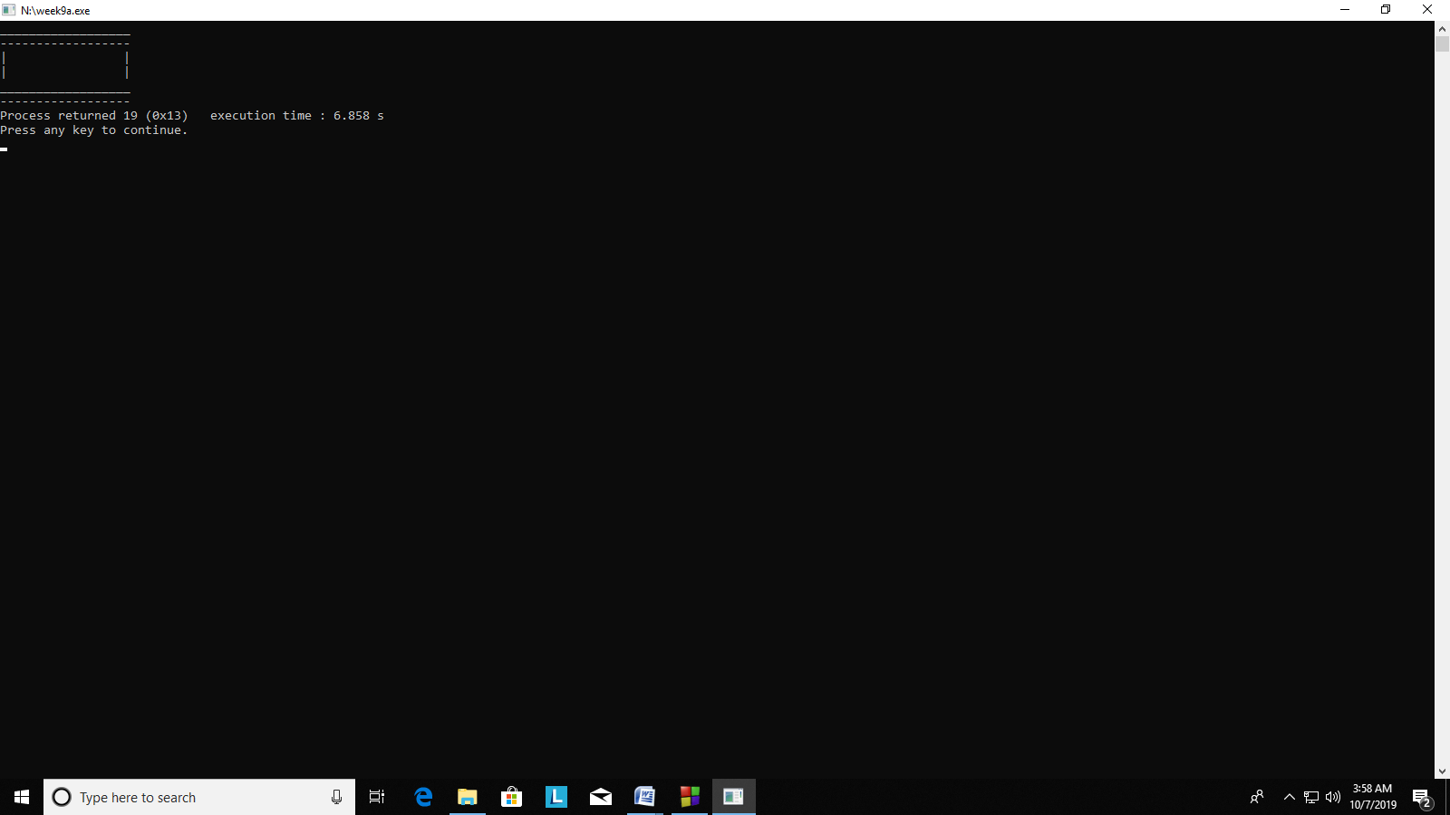

(e)

#include <stdio.h>

int main()

{

printf("\\ /");

printf("\n\\/");

printf("\n/\\");

printf("\n/ \\");

}

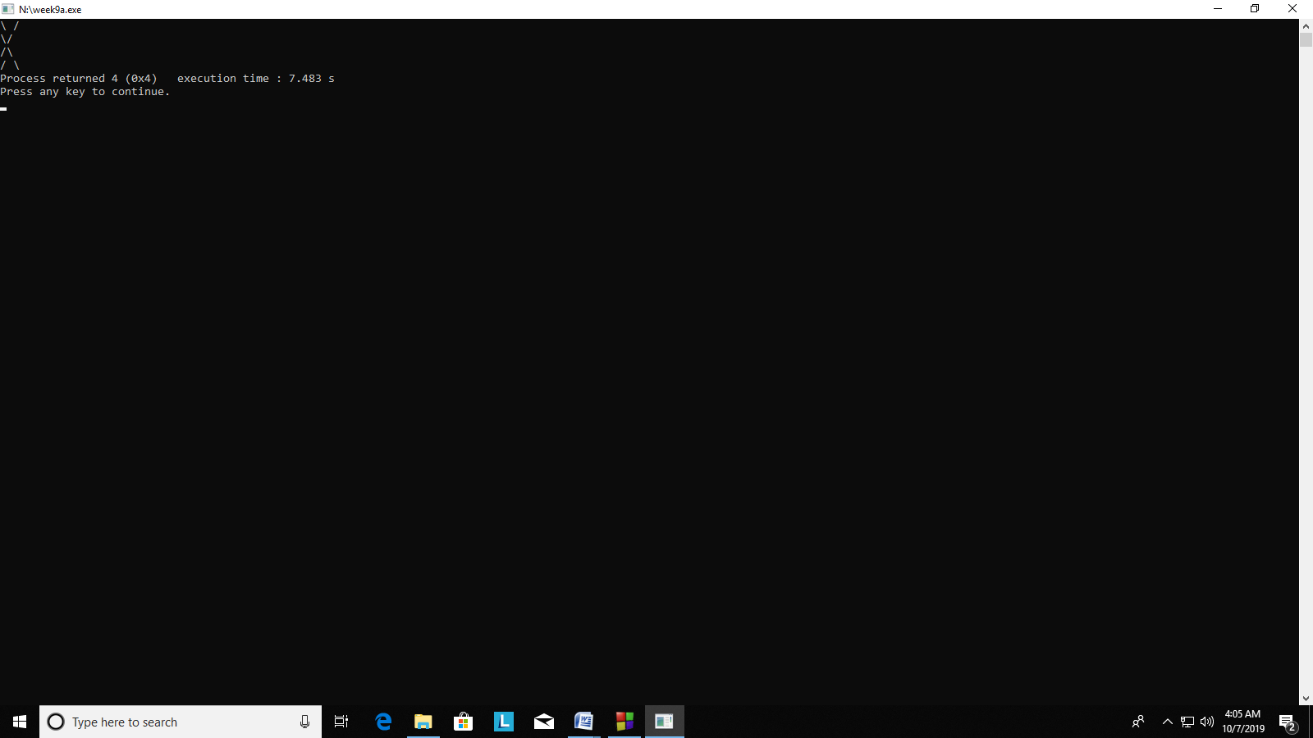

(f)

#include <stdio.h>

int main()

{

printf("@ @");

printf("\n #");

printf("\n ---");

printf("\n ---");

}

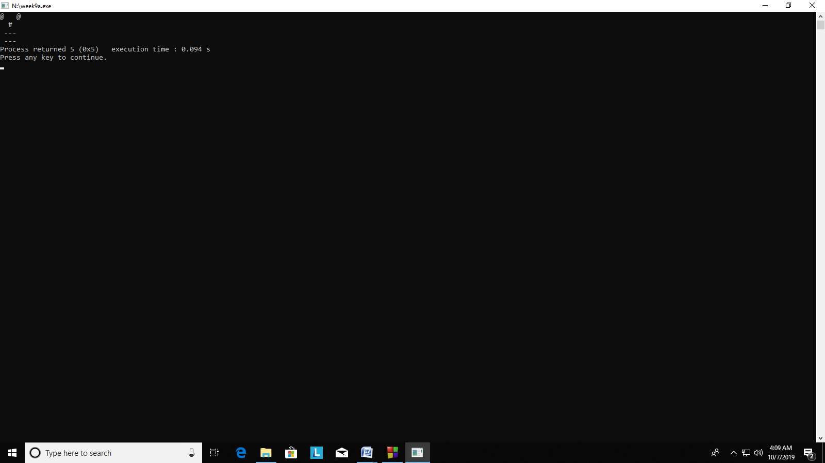

(g)

#include <stdio.h>

int main()

{

printf(" %%%%*%%%%");

printf("\n %%%%,%%%%");

printf("\n )/(");

printf("\n |/|");

printf("\n (_)");

}

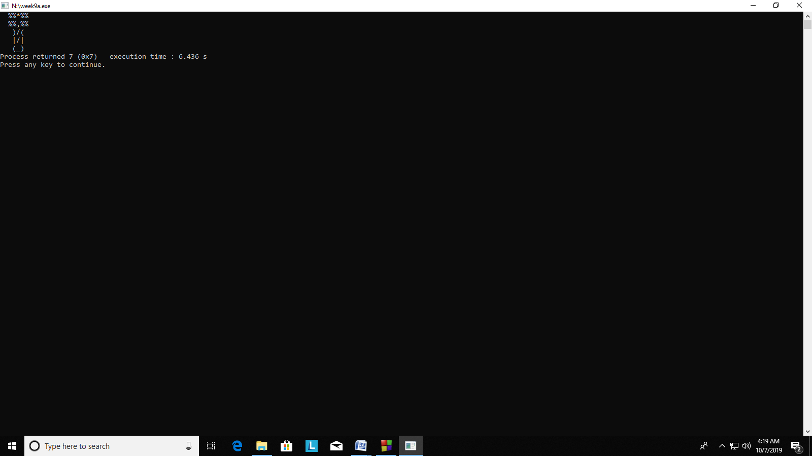

Question 8

#include <stdio.h>

int main()

{

printf("Welcome to C programming");

}

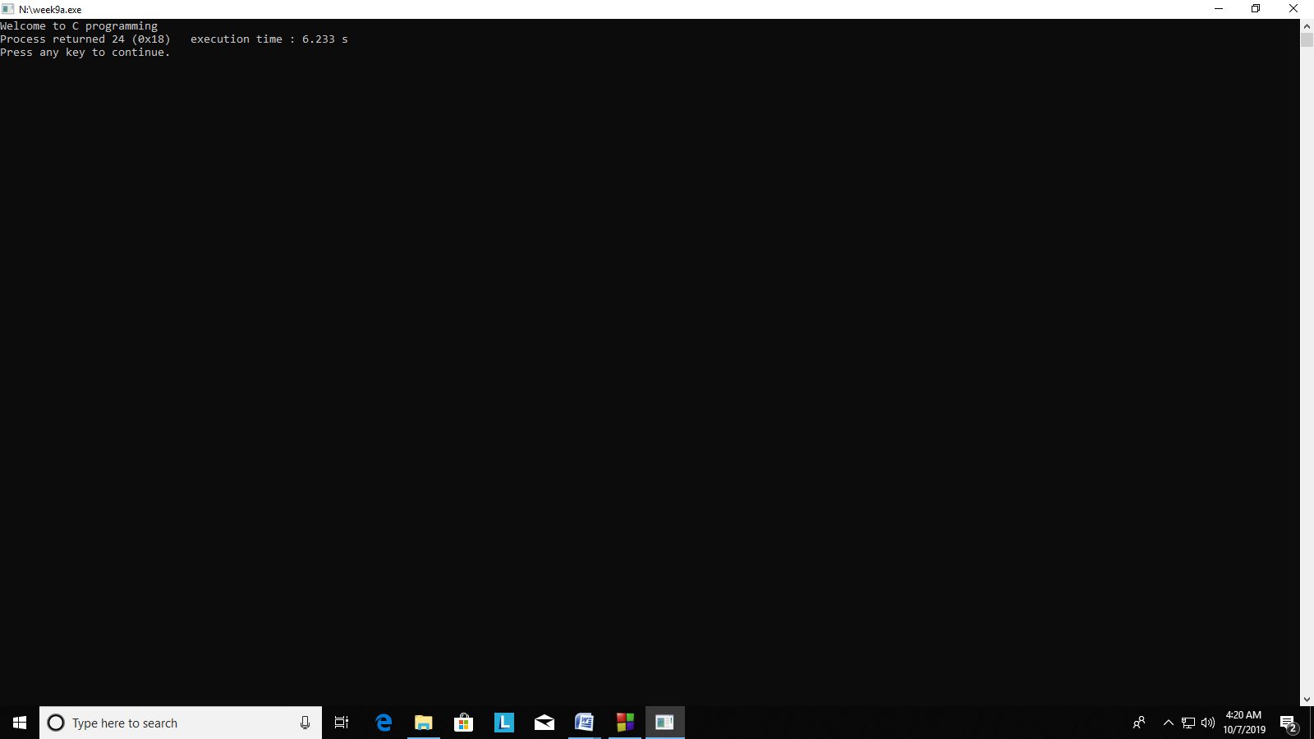

Question 9

#include <stdio.h>

int main()

{

printf("Name: Shubham Garg");

printf("\nCourse: Btech");

printf("\nBranch: CSE");

printf("\nyear: 1st");

}

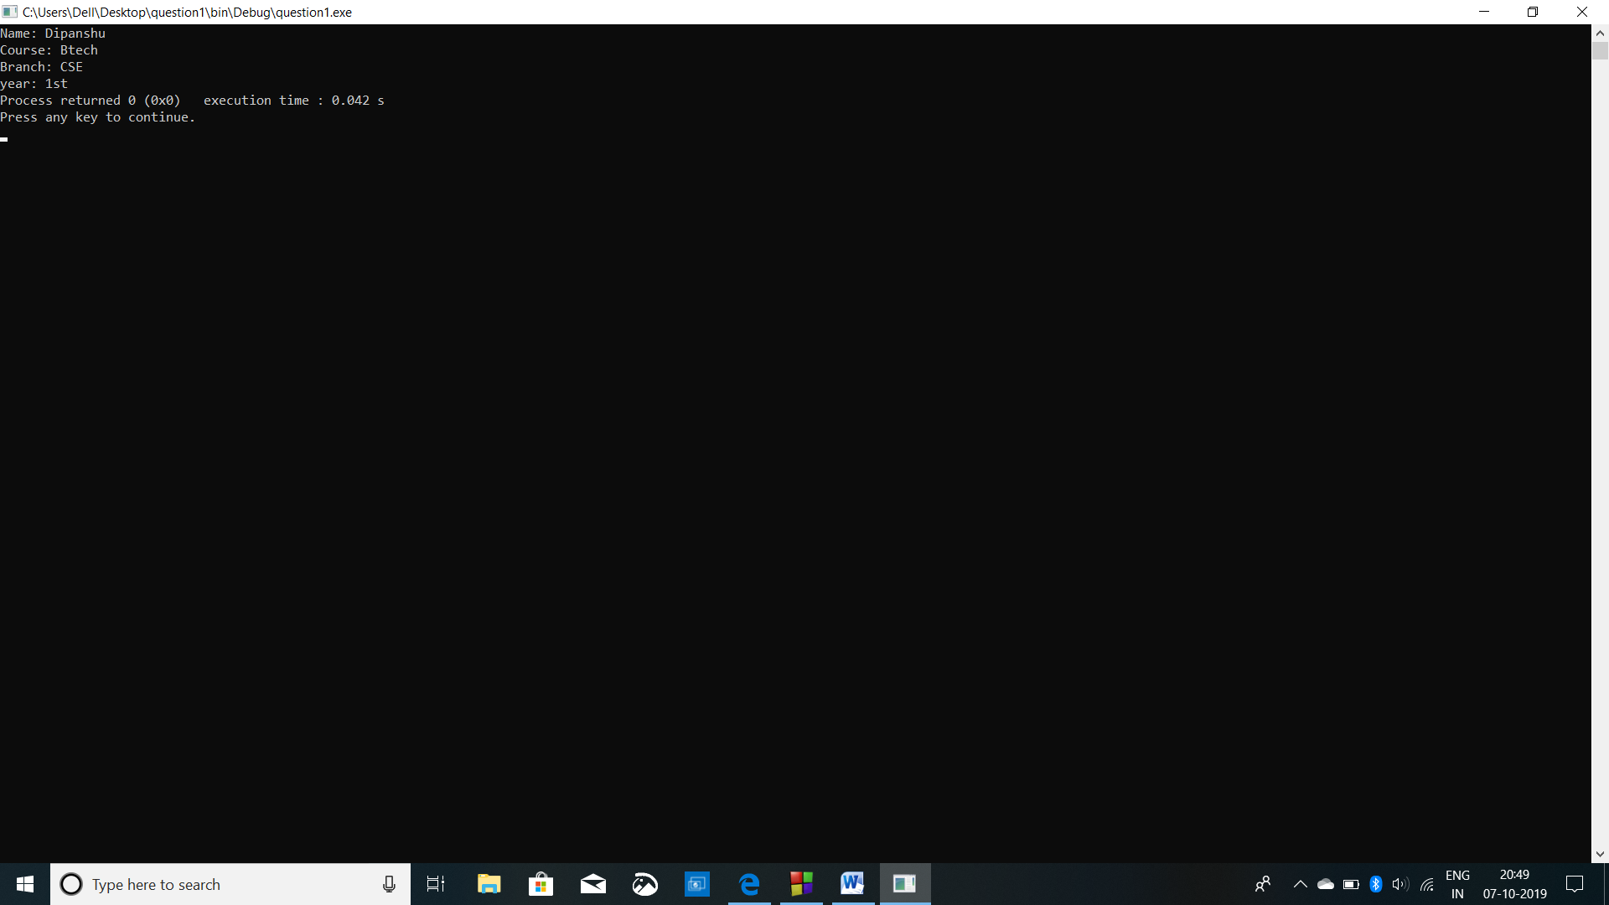

Question 10

#include <stdio.h>

int main()

{

int a,b,c,d,e,f;

printf("enter the five numbers:");

scanf("%i%i%i%i%i",&a,&b,&c,&d,&e);

f=a+b+c+d+e;

printf("the sum of the five numbers is: %i",f);

}

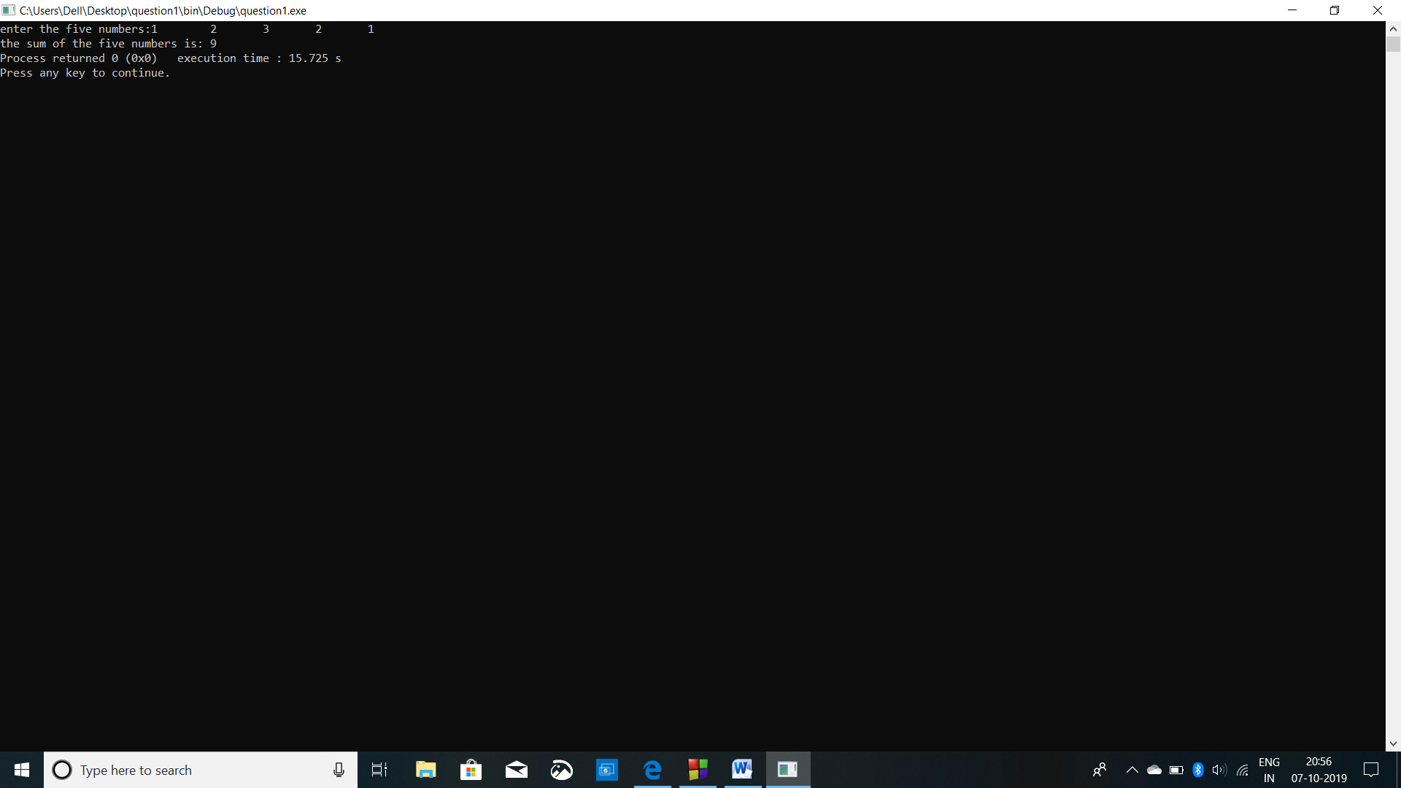

Question 11

#include <stdio.h>

int main()

{

printf("the size of the datatype is %lu",sizeof(int));

printf("\nthe size of the datatype is %lu",sizeof(float));

printf("\nthe size of the datatype is %lu",sizeof(double));

printf("\nthe size of the datatype is %lu",sizeof(char))

}

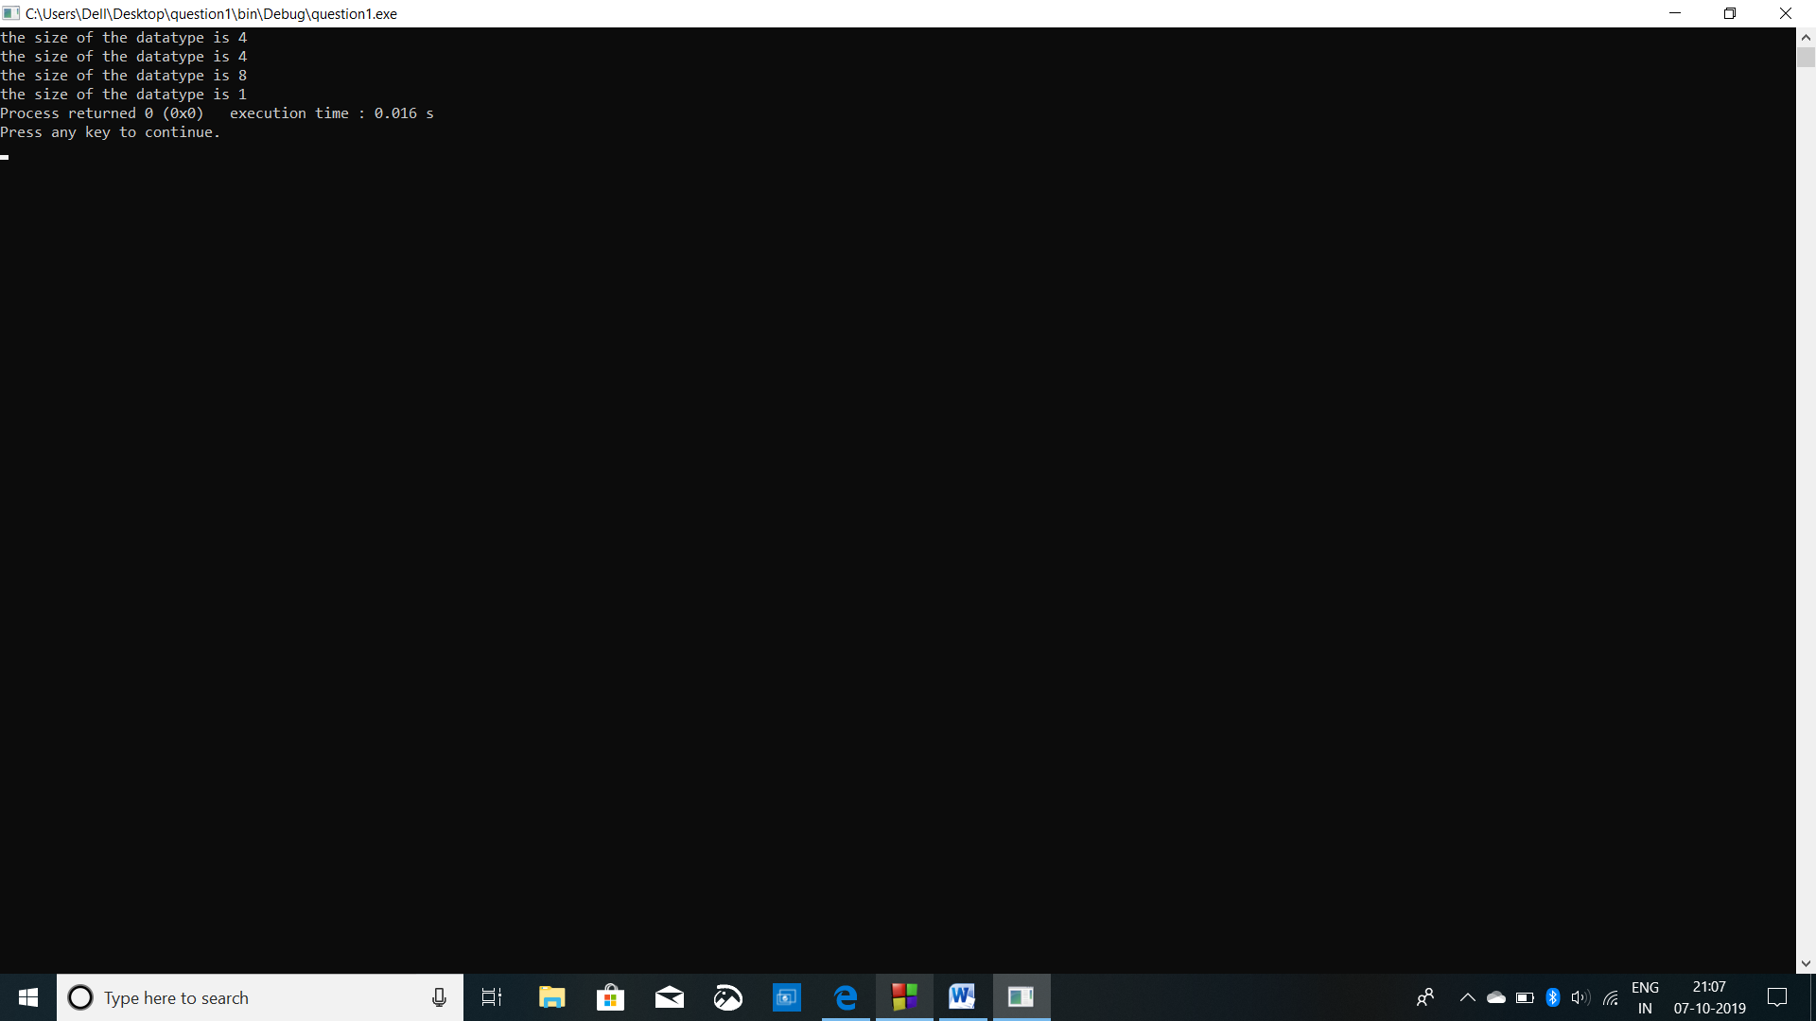

Question 12

#include <stdio.h>

int main()

{

char name[10];

char course[10];

char branch[10];

char year[10];

printf("enter your name:");

scanf("%s",&name);

printf("\nenter your course:");

scanf("%s",&course);

printf("\nenter your branch:");

scanf("%s",&branch);

printf("\nenter the year:");

scanf("%s",&year);

printf("\n\nyour name is %s", name);

printf("\nyour course is %s", course);

printf("\nyour branch is %s", branch);

printf("\nyear is% s", year);

}

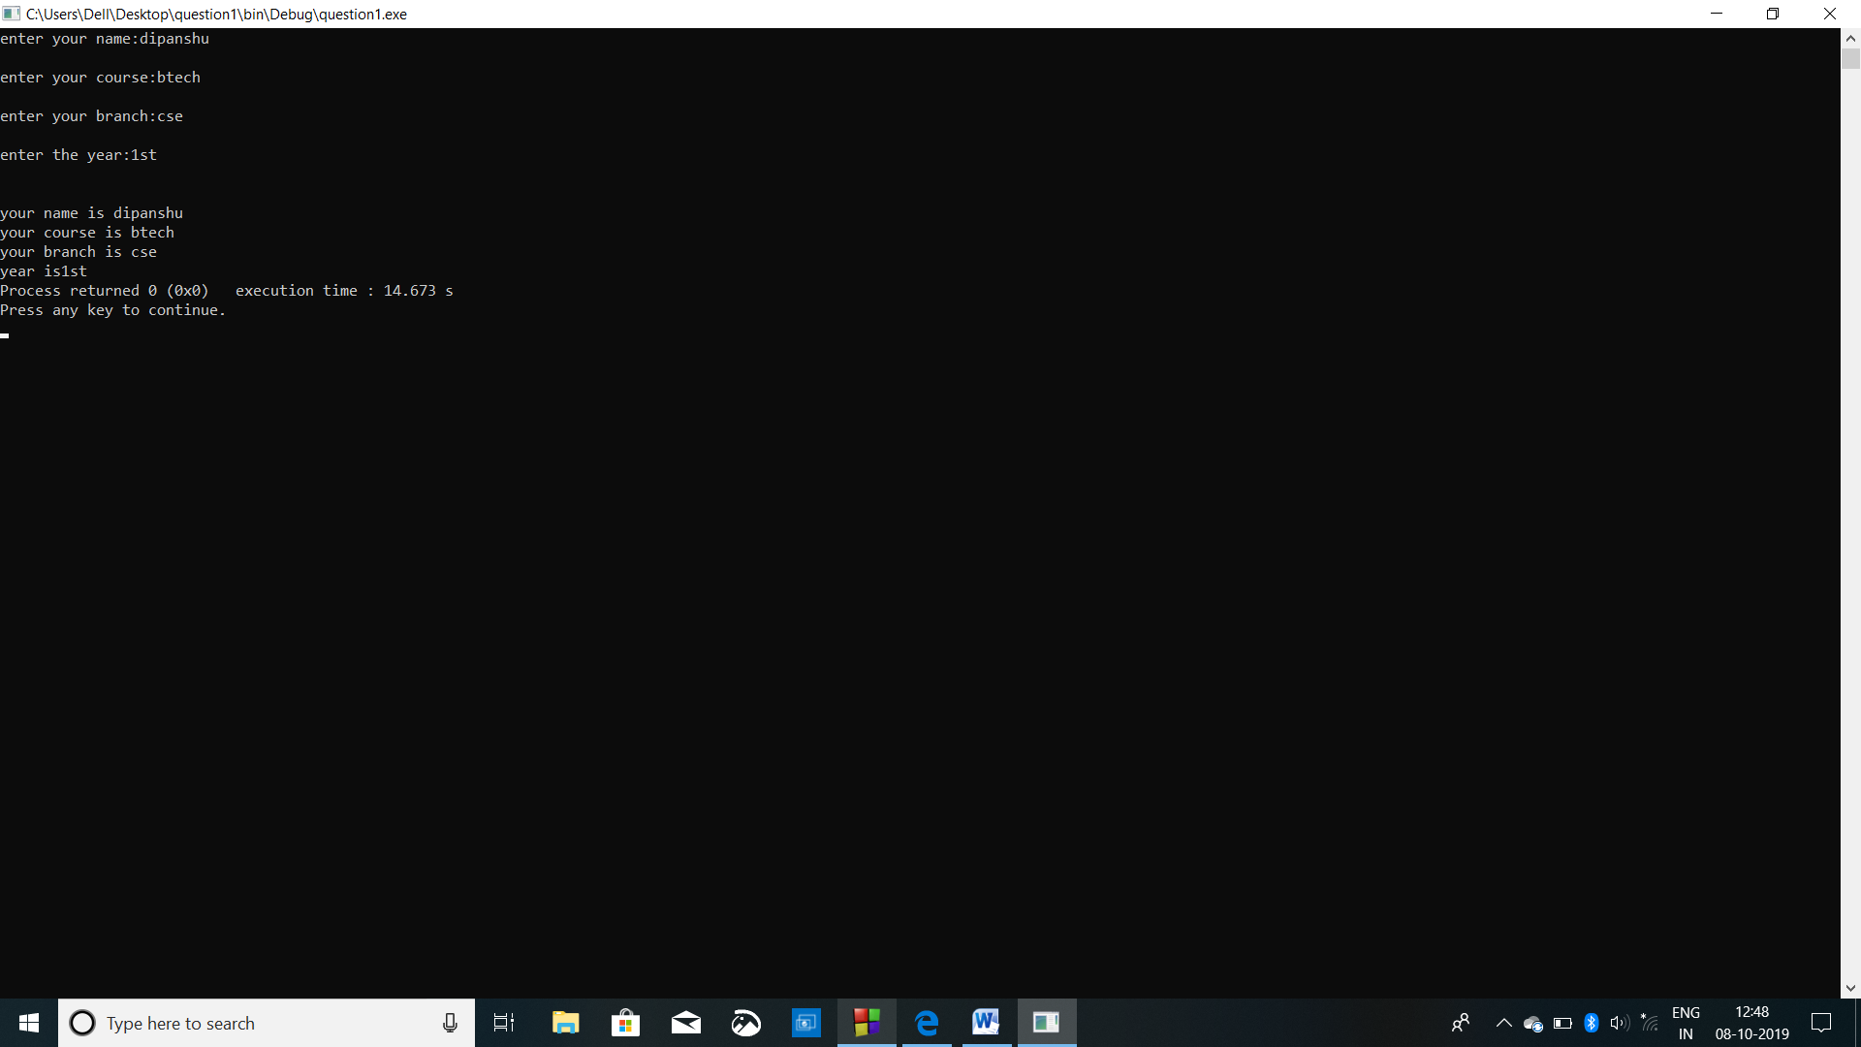

Question 13

#include<stdio.h>

#include<conio.h>

int main()

{

char name[10],Branch[6],martial[10];

int year,age;

printf("\t RESUME \n\n");

printf("Enter your name : ");

scanf("%s",&name);

printf("Enter your age : ");

scanf("%d",&age);

printf("Enter your Martial Status : ");

scanf("%s",&martial);

printf("Enter your year of Graduation : ");

scanf("%d",&year);

printf("\n\nHi, %s \n age : %d \n Martial Status : %s\n Year of Graduation : %d\n\n\n\n",name,age,martial,year);

}

